Vacuum lancing device

YS-CXB3

The Yasee pain free vacuum lancing device can help make lanc- ing easy. Drawing blood to the surface using vacuum technolo- gy allows for a shallower prick compared to traditional lancing devices. By controlling the depth with a cushioned contact tip and rotatable cap with 12 ﬁxed depth settings , users can enjoy a unique, clinically proven painless experience.



**Pain Free**

**Test Anywhere**

Vacuum technology and dual springs ejection control technology minimize pain，Elimi- nates severe puncture marks & swelling,

Gives ﬁngers a break using vacuum and depth control to test other sites such as palm.



**Stop Squeezing**



**Check More Often**

With vacuum, Yasee brings blood to the surface and forms the perfect drop.

Re-poking and squeezing is a thing of the past.

Removes the obstacles of pain and trauma so people can start checking blood glucose levels as doctors prescribe.

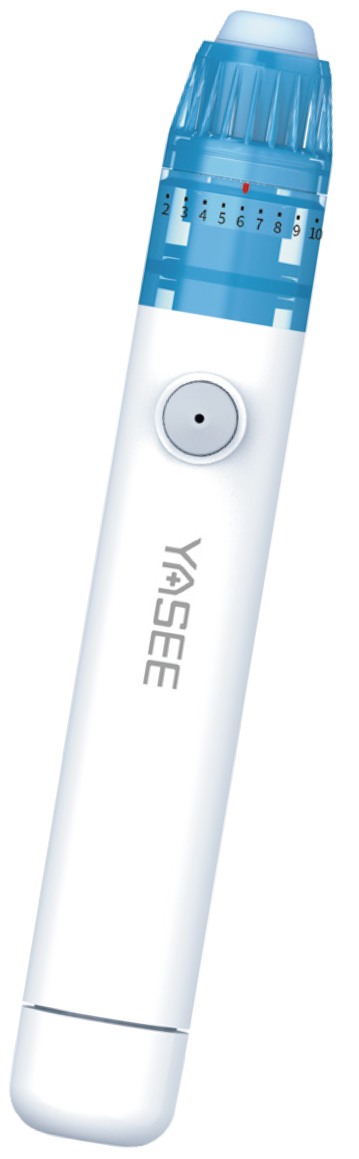

Qingdao Yasee Medical Equipment Co.,Ltd. Tel: +86 532 68012807 Email: [sales@yasee.org](mailto:sales@yasee.org) [http://www.yasee-med.cn](http://www.yasee-med.cn/)

WORKING PRINCIPLE

YASEE pain free vacuum lancing device uses negative pressure technology to adsorb and stabilize the blood collection area, supplemented by ejection control technology to accurately control the strength and depth of the penetration. This enables stable blood sampling in the subcutaneous comfort zone, eﬀectively reduces the pain of lancing and accelerates wound healing.

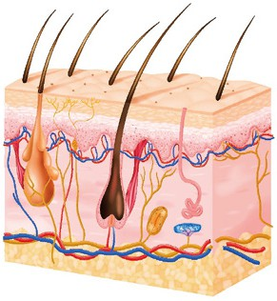

senseless



tactile

Capillaries

Nipple layer

**0.3 mm**

Epidermis

**0.3 mm**

**“Comfort zones ”**

Epidermis

Nociceptors

Capillaries

Comfort zones

pain

Reticular nerve from

Reticular layer

**1.2 mm**

Reticular nerve from

**1.5 mm**

**“Paiin”**

|  |  |
| --- | --- |
|  | Negative pressure blood collection technology, gentle touch, inhibit pain sensory nerve conduction. Suction and stabilisation of the skin in the area of blood collection, not easy to be stuck out of place. |
|  | The dual spring ejection control technology eliminates the excess vibration waves during lancing process, makes the lancing more accurate, quickly release the lancet and rebound, reduces lancing stinging sensation |
|  | Designed with ultra-precise depth control using 12 gears (0.083mm each gear) of contact tips. Get the consistent amount of blood in seconds while avoiding pain nerves and giving a near painless experience. |
|  | Replacement silicone cushions in 3 diﬀerent thicknesses for diﬀerent people to avoid blood contamination. |

COMPARE WITH TRADITIONAL LANCING DEVICE

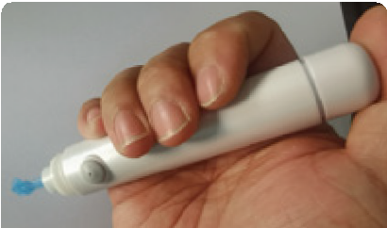

9

Remove the vacuum cover, press the pusher and insert the lancet tip into the protective cap of the lancet, which has been put aside for the time being.

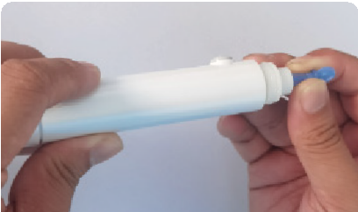

10

Remove the lancet and dispose of it in accordance with medical waste disposal methods

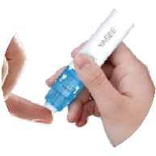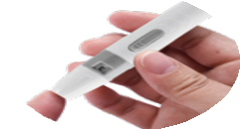

**Yasee pain free vacuum lancing device**

**Traditional lancing device**

**Soft**

The lancet reaches just the capillaries beneath the skin without damaging the adjacent tissues, such as pain nerves

Blood collection is easy to penetrate the pain

nerve and the pain of blood collection is strong

**Stable**

Negative pressure adsorption technology to stabilize the skin in the blood collection area

Unable to control the stability, jittery during blood

collection, easy to stick the wrong way

**Fast**

Dual spring ejection control technology for fast needle release and quick rebound

Single spring ejection, slow needle return

**Slim**

12 levels of ﬁne adjustment for precise blood collection

Less than 6 gears, No ﬁnesse, more pain

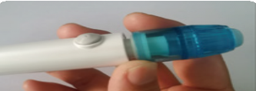

1

Remove the vacuum tip from the front of the lancing device.

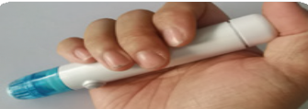

2

Before loading the lancet, push the priming button down until it clicks.

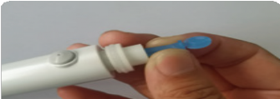

3

Insert the lancet into the bottom of the central lancet holder.

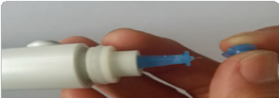

4

Rotate and unscrew the protective cap of the lancet and set it aside.

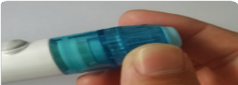

5

Put the vacuum cover back on and make sure it is ﬁtted to the bottom

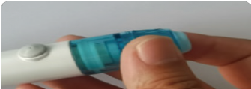

6

Turn the adjusting tip to select the desired level.

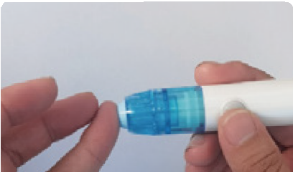

7

Using appropriate force, press the tip of the silicone pad onto the blood collection area at the front of the ﬁnger.

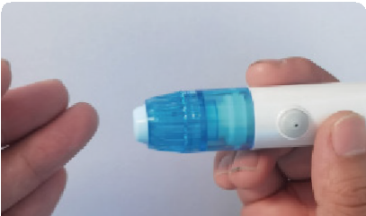

8

Press the trigger button, wait 1-2 seconds and then release the ventilation hole on the trigger button and then remove the lancing device.